Website Proposal

# 1. Introduction

This proposal outlines the plan to create a new website inspired by 'The Brokerage Inc.' The objective is to design a user-friendly and informative platform that caters to our client's needs. The website will be developed on WordPress, allowing for easy content management and scalability. Our approach will ensure a blend of aesthetic appeal and functionality, aimed at enhancing user engagement and satisfaction.

# 2. Project Scope

The website will consist of the following pages and features, each designed to offer specific information and services to the users: Home, Our Company, What We Offer, Testimonials, Resources, Contact Us, Privacy Policy, Staff Resources, Webinars & Events, and Articles & Podcasts, Blogs and the inner pages of the website. Each page will be developed with a focus on user experience, incorporating SEO practices to improve visibility and engagement.

# 3. Development Timeline

The project timeline will be consisting about 1 month. The timeline includes phases for planning, design, development, testing, and deployment. Regular updates will be provided to ensure the project remains on track and meets all client expectations.

# 4. Implementation Plan

The implementation will follow a structured approach:   
- Planning: Defining project scope, objectives, and timelines.   
- Design: Creating wireframes and design mockups for each page.   
- Development: Building the website on WordPress, customizing themes and plugins as required.   
- Content Creation: Writing and organizing content for each page, ensuring it aligns with SEO strategies.   
- Testing: Conducting thorough testing for functionality, usability, and responsiveness.   
- Deployment: Launching the website and monitoring its performance for any immediate fixes.

# Home

Introduction to the company, including a brief overview of services and unique value propositions.

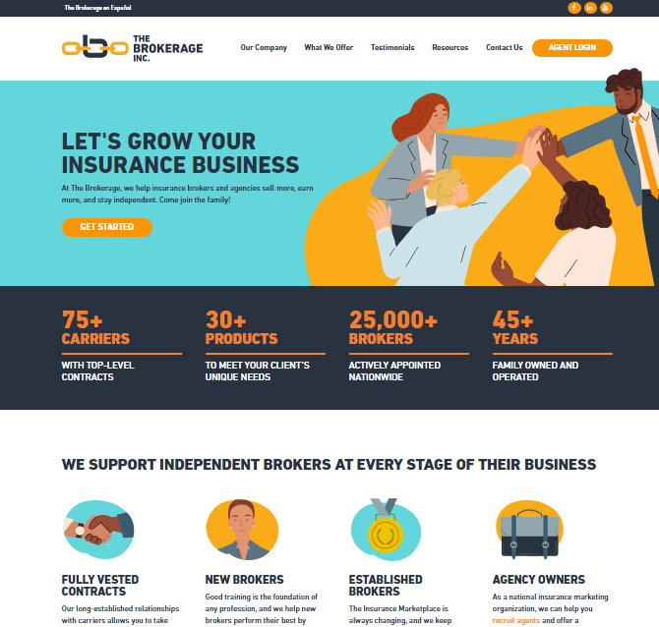

# Our Company

Detailed background information on the company, its history, mission, and vision.

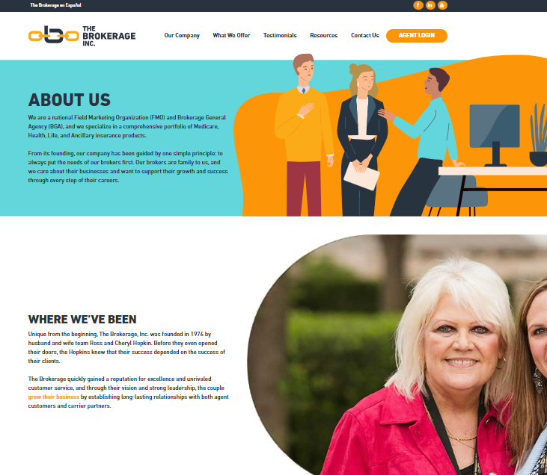

# What We Offer

Comprehensive details on services and products offered, including any specializations.

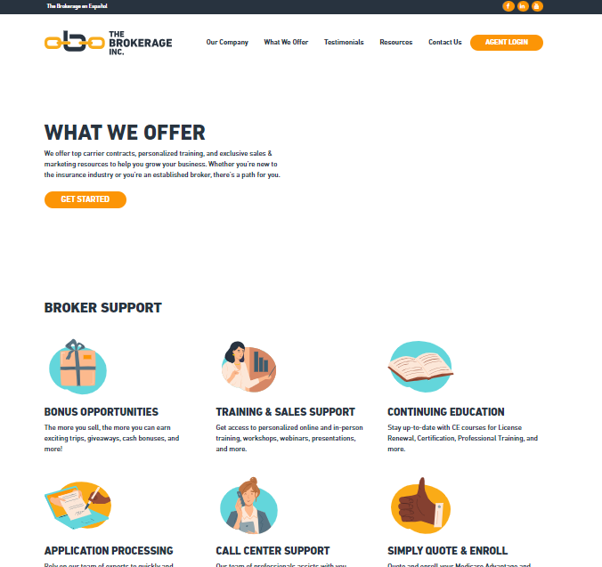

# Testimonials

Client testimonials and case studies showcasing the impact of the company's work.

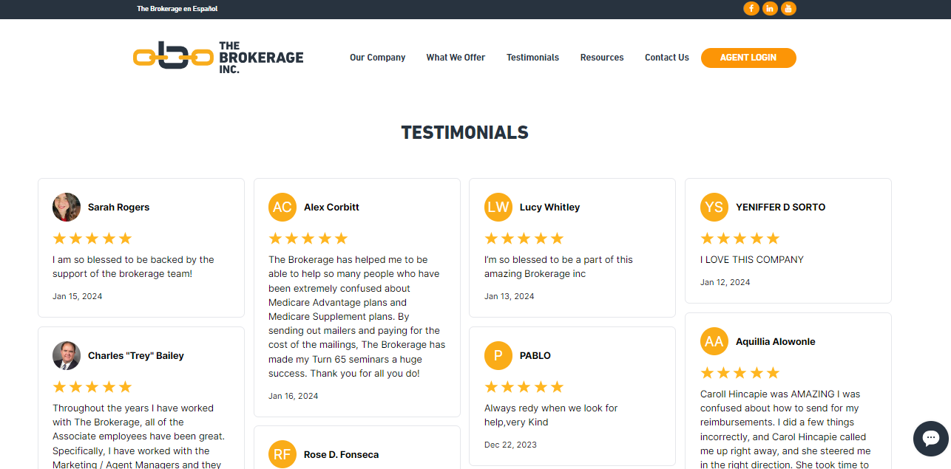

# Resources

A repository of downloadable resources, guides, articles, and tools for clients.

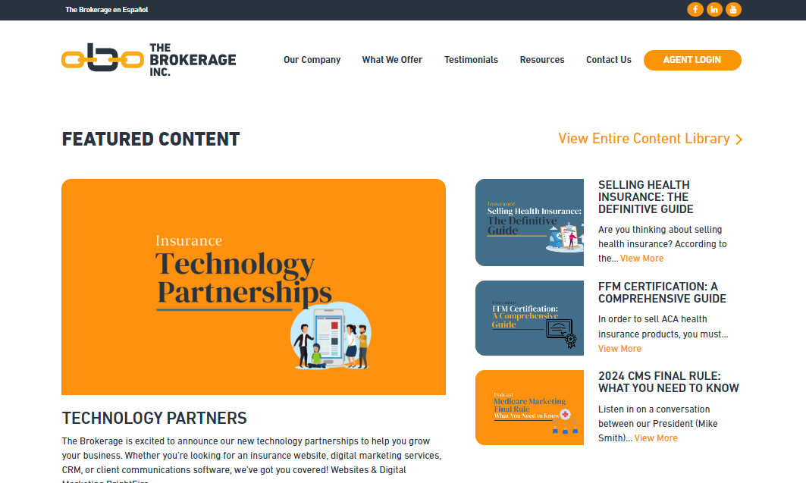

# Contact Us

Contact information, including an inquiry form, map, and directions to company locations.

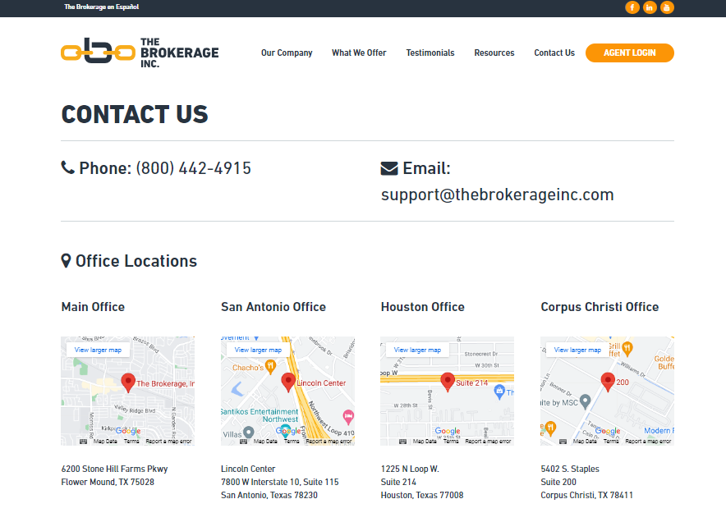

# Privacy Policy

Explanation of the website's data handling practices and user privacy protections.

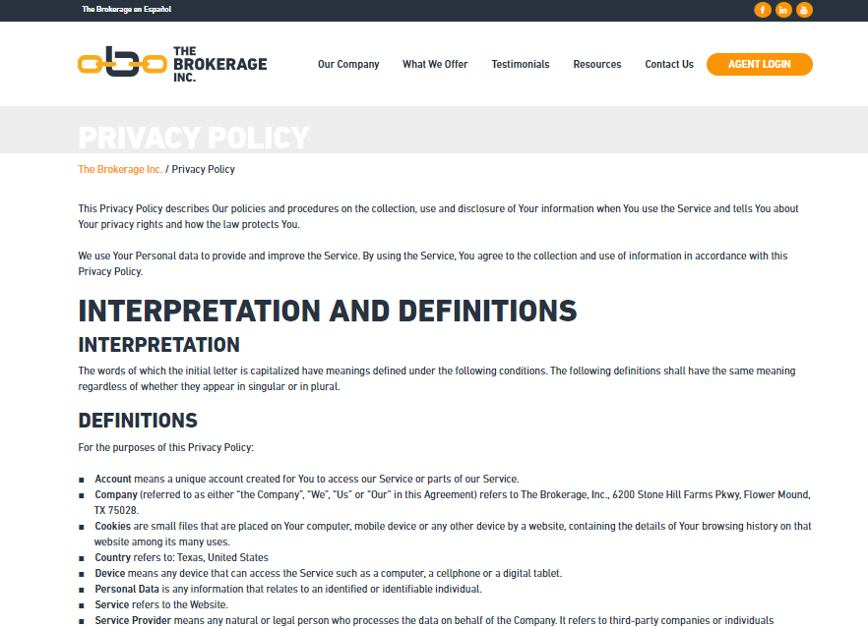

# Careers

The 'Careers' page will be dedicated to showcasing current job openings and providing a detailed overview of the benefits of working with our company

# 

# Articles & Podcasts

Educational content aimed at providing value and engaging the website's target audience.

